Type or paste the title of your manuscript here

Name SURNAMEª*, Name SURNAME^{b}
ª Department, Faculty, University, Address: street, postal code, city and country
^{b} Organization, Address: street, postal code, city and country

A B S T R A C T
K E Y W O R D S
- Climbing Robot
- Structural Damage
- Optimal Controller
- …

NOTE: Provide 3 - 6 keywords in alphabetical order using bullet points.

In this study, the system design and prototype manufacturing were carried out, which enables the structural damage control processes to be carried out in a much shorter time and cost, as a result of reporting lightning and hail events in the maintenance carried out in the hangars.
.............................................
Unlike these two methods, the system uses the force created by the propellers on it to hold onto the surface. The images on the inaccessible surfaces were transferred to the ground, allowing the damage on the surfaces to be seen. The developed system can hold onto surfaces with different slopes thanks to the thrust created by EDF engines.

NOTE: Type or paste your abstract here as prescribed by the instructions for authors (limits 150-200 words). The page limits are between 4 and 10 pages.

Introduction (Heading 1)
This document is a template for Microsoft Word versions. You can use it to prepare your manuscript.

1.1. Heading 2: use this style for level two headings
Use this level of style for this subsection.

Heading 3: use this style for level three headings
Use this level of style for subsection.

Math (Heading 1)
Use the Microsoft Equation Editor for equations in your paper. Please submit math equations as editable text and not as images and refer to the equations using their numbers within the text i.e. “It can be seen from Equation (1) that”
$f\left(x\right)=a_{0}+\sum_{n=1}^{∞}{\left(a_{n}\cos{\frac{nπx}{L}}+b_{n}\sin{\frac{nπx}{L}}\right)}$ (1)

Figures & Tables (Heading 1)
Please ensure the figures and the tables included in the single file are placed next to the relevant text in the manuscript. Position figures and tables at the top and bottom if possible.
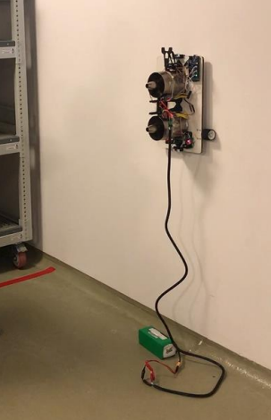
Fig. 1. Tilted view

Table 1. Years & values
Years | Column 1 | Column 2 | Column 3
2020 | 10 | 20 | 30
2021 | 10 | 20 | 30
2022 | 10 | 20 | 30
2023 | 10 | 20 | 30

Appendix
Appendixes, if needed, appear before the acknowledgment.

Acknowledgment
if any, should be placed here before the references section without numbering.

References
Cite the references in the text using their reference numbers i.e. [1]. Use APA style with numbers.
- Johnson, R. J., & Suid, M. H. (2015). Pressure control of wall climbing robot using PID controller. ARPN Journal of Engineering and Applied Sciences, 10(21), 9825-9829.
- Duckworth, A. L., Quirk, A., Gallop, R., Hoyle, R. H., Kelly, D. R., & Matthews, M. D. (2019). Cognitive and noncognitive predictors of success. Proceedings of the National Academy of Sciences, USA, 116(47), 23499–23504.
- Jackson, L. M. (2019). The psychology of prejudice: From attitudes to social action (2nd ed.). American Psychological Association.
- Lee, C. (2020, February 19). A tale of two reference formats. APA Style Blog. https://apastyle.apa.org/blog/two-reference-formats

* Corresponding author: E-mail:

